

**CAPSTONE PROJECT REPORT**

**PROJECT TITLE**

Development of an quick personal protofile (resume)

**REPORT SUBMITTED BY**

Karanam Meghana(192321126)

**COURSE CODE:** CSA1087

**COURSE NAME:** software engineering for web development

**INTRODUCTION :**

To create a dynamic and user-friendly web application that allows users to generate customized resumes tailored for specific job roles. The platform focuses on helping users prepare professional resumes efficiently.

**Key Features :**

**1. Interactive Form:**

* Fields for personal details: Name, Contact Information.
* Dropdown to select a job role (e.g., Software Developer, Graphic Designer, Project Manager, Data Analyst).
* Input areas for skills, work experience, and education.

**2. Role-Based Resume Customization:**

* Dynamic descriptions for each job role.
* Highlights relevant skills and experience based on the selected role.

**3. Real-Time Preview:**

* Users can view a formatted resume immediately after filling out the form.

**4. Responsive Design:**

* Ensures the platform is accessible on various devices (desktop, tablet, mobile).

**5. Validation:**

* Form fields are validated to ensure proper input before generating the resume.

**6. Extensibility:**

* Code structure allows for easy addition of new job roles and features.

**TECHNOLOGIES:**

**1.HTML:**

* Structure of the webpage.
* Form elements for user input.

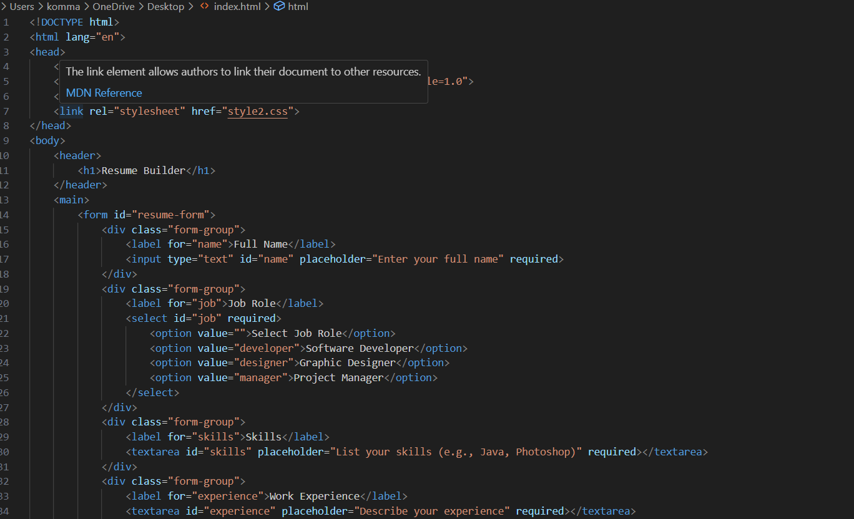

**2. CSS:**

* Styling for a professional and modern look.
* Ensures responsiveness and user-friendly interface.

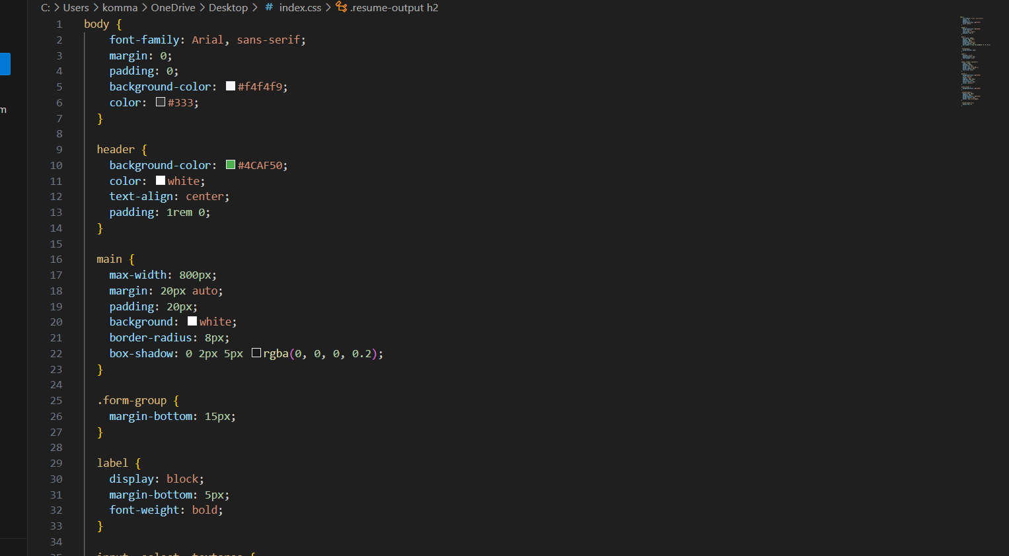

**3.JavaScript:**

* Form validation to ensure all required fields are filled.
* Dynamic generation of resume content based on user input.
* Interactive display of generated resumes.

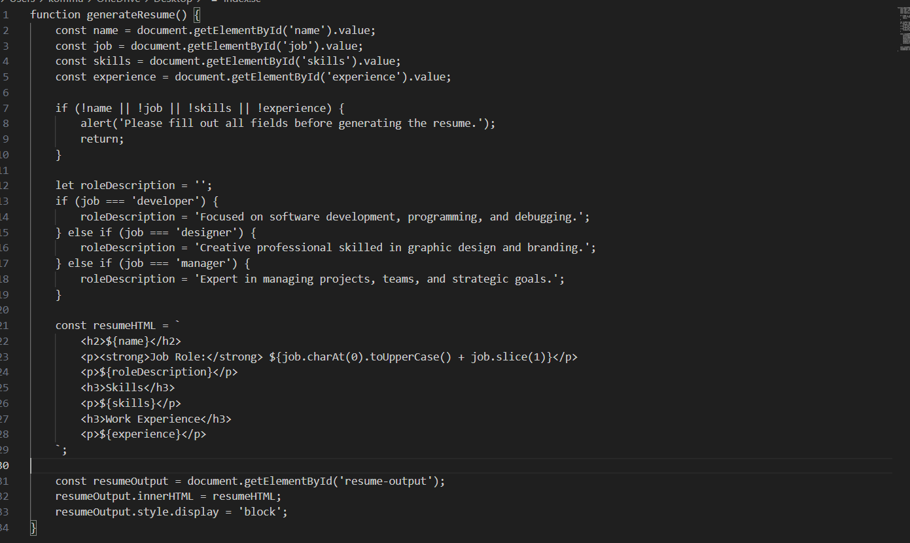

**PROJECT WORKFLOW:**

**1. Planning:**

* + Defined the purpose and scope of the resume builder.
  + Identified key features and technologies.

**2. Design:**

* Created a layout for the form and output sections.
* Designed CSS styles for a clean, modern look.

**3. Development:**

* Built the HTML structure for the form.
* Implemented dynamic functionality using JavaScript.
* Integrated CSS for responsive design**.**

**4. Testing:**

* Ensured compatibility across browsers and devices.
* Validated form inputs and dynamic content generation.

**5. Deployment:**

* Prepared the project for web hosting.
* Deployed on a live server for end-user access.

**USAGE INSTRUCTIONS:**

**1.Access:**

* Open the project in any modern web browser.

**2. User Flow:**

* Enter personal details and select a job role.
* Fill in skills, work experience, and education.
* Click "Generate Resume" to view the formatted output.

**3. Output:**

* View a role-specific, professional resume on the same page.

**4. Further Customization**:

* The generated resume can be edited for additional personalization.

**Screenshots:**

**1.Form Page:**

* Shows input fields for user details and job role selection.
* 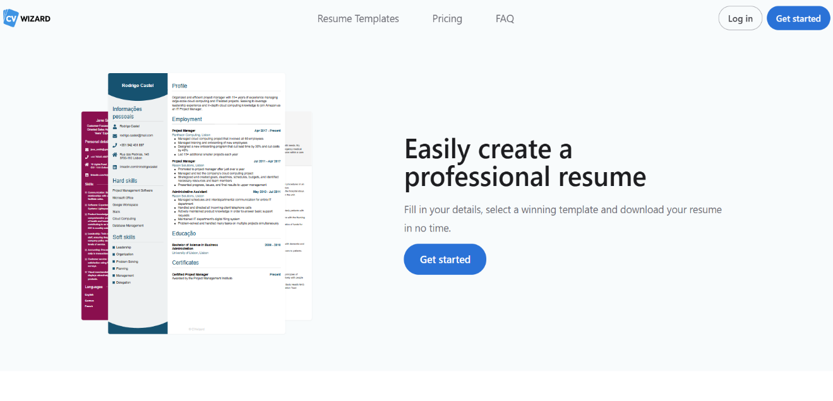

**2. Generated Resume:**

* Displays the tailored resume based on user input.

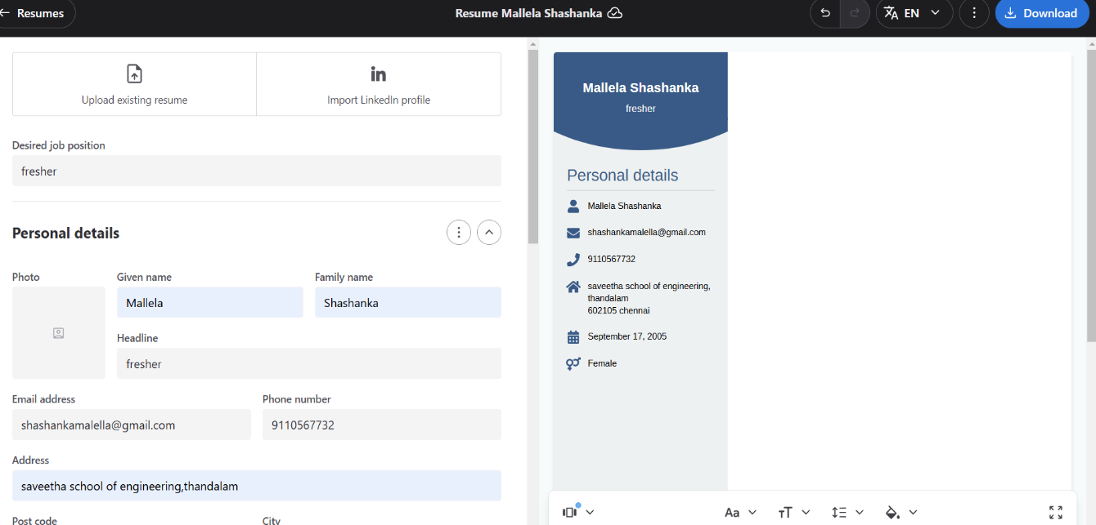

**CONCLUSION:**

The Resume Builder Project aims to simplify the process of creating professional resumes for job interviews. With its dynamic features and user-friendly interface, it empowers users to present their qualifications effectively. This tool is an essential step towards modernizing the job application process.